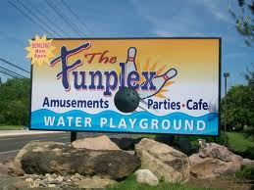
3320-24 Route 38, Mount Laurel, NJ

Departure from XL: 9:30 AM
Arrival at trip: 10:00 AM
Departure from trip: 2:30 PM
Arrival at XL: 3:00 PM
Campers will enjoy unlimited Indoor and Outdoor Attractions PLUS Waterpark. Arcade tokens and bowling are not included.
PLEASE REMEMBER:
- Camp shirt must be worn.
- Bring a packed lunch (no glass).
- After lunch, campers can purchase snacks.
- Bathing suit must be worn to camp under clothes. Water shoes are permitted but not required but recommended.
- Apply sunblock before coming to camp.
- Bring sunscreen, towel in a backpack.
- Campers will be instructed to apply sunscreen after lunch.
- Do not bring a flotation device as they are not permitted.
- Campers will remain with their grade for the duration of the trip.
- Campers will eat lunch in the designated lunch area.
- Campers will change when they return to XL so please bring a change of clothes to leave at XL.
- Campers are not permitted to change on any field trips.
- No souvenirs will be purchased on this trip.

