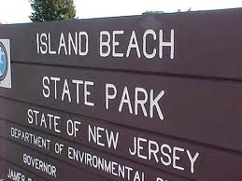
Island Beach State Park
Central Avenue, Seaside Park, NJ
Departure from XL: 9:30 AM
Arrival at trip: 10:45 AM
Departure from trip 2:30 PM
Arrival at XL: 4:00 PM

This is one of our camper’s favorite trips!! We have been doing this trip for over 11 years!!! This is part of the NJ State park and it is very clean and child friendly. Please note that campers are always in the water with our staff. They are not permitted to go above their knees. We bring buckets and shovels and water toys for them to play with. Campers will be escorted to the bathrooms by our staff.

PLEASE REMEMBER:
- All campers must wear their camp shirt over their bathing suit.
- Campers must wear their bathing suit to camp under their clothes. They will not have time to change prior to the trip. (Campers that do not have a bathing suit will not be permitted to attend the trip)
- All campers should apply sunblock before coming to camp.
- Bring sunscreen, a hat, a towel and a change of clothes!
- After lunch they will be reminded to reapply sunscreen. Our staff is available to assist the campers with their sunscreen.
- Do not bring a flotation device as they are not permitted at this beach.
- Bring a packed lunch (no glass). Please pack extra snacks as the campers get hungry at the beach. We serve cookies when they get on the bus and water is available to them all day on the beach.
- Campers will shower off in the outdoor shower and then wear their bathing suits back to the facility. They will change once they are back at camp.
- Campers are not permitted to change unless it is an emergency on any of our field trips.

