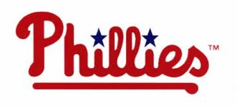
Vs. Los Angeles Dodgers
Game time 1:05 pm

Departure from XL: 10:30 AM
Arrival at trip: 11:30 AM
Departure from trip: 4:00 PM
Arrival at XL: 5:00 PM

After arriving at the Stadium campers will have a chance to walk through the stadium with their groups and purchase snacks and souvenirs before the start of the game.
We will bring water for the campers, but they should also bring a drink with them in their bag (unopened).

Campers will remain with their group and our staff the entire trip.

PLEASE REMEMBER:
- All campers must wear their camp shirt.
- Bring a packed lunch (no glass).
- Campers will eat lunch in the designated lunch area before entering the game.
- Unopened water bottles are allowed in the park.
- Apply sunblock before coming to camp. All campers should bring sunscreen to reapply.
- A hat is a very good idea as it will be sunny!!

