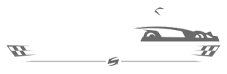
Speed Raceway
1103 Route 130 South, Cinnaminson, NJ‎

Departure from XL: 1:15 PM
Arrival at trip: 2:00 PM
Departure from trip: 4:00 PM
Arrival at XL: 4:30 PM
PLEASE REMEMBER:
- Camp shirt must be worn.
- Sneakers and socks are recommended.
- Campers will eat lunch in the designated lunch area.
- After lunch, snack purchases will not be available.
- Campers will have time to play the games. $10 game card is included in the price of the trip.
- Water will be available throughout the day.
- All campers must have a signed waiver to attend the trip. Waivers will be available on the website and also at the check in desk.

